Andrew Milligan and Sarah Anderson - Proposed State System of Accountability
Fordham Institute Design Competition - January 2016

The inner workings of state accountability systems – algorithms, cut scores, comparisons, data cleaning, uploads and downloads – and the spirit that animates them – values, judgments, rage at inequities and fears of exposing them – have for years left the lab and entered the world as School Report Cards, stitched-together Frankenstein monsters purporting to be whole. The challenge to those of us who play Dr. Frankenstein is to build a single system that serves diverse audiences and purposes. We therefore begin by exposing the stitching to describe the needs of those we hope to inform: families and the state stewards of education.

These audiences have essentially the same goal: a high quality seat in a public school for their own children, and for all children. School accountability must help families choose the right seat and advocate for the best education for their children. Similarly, it must help the state ensure that there are such seats for students who are often are denied them. When we judge schools, however, these two slightly different takes on the same goal mean that families and the state need different information. The information any one family requires depends on both its values and its particular children’s learning needs. And just like that our two audiences have become many thousands. A state system cannot meaningfully judge the good from the great from the terrible for all. Thankfully, it need not. Families, particularly those that have many options across different systems, have other sources of information for these judgments within their communities. The state report card should support these decisions with information, without attempting to be the sole measuring stick for everyone.

By freeing school accountability from the expectation that it contain within it the diverse, often competing, values of every family and community, we make room to build a system around one deeply held belief. While conflicting interests remain at the state level, here we must have the courage to make a choice. The authors believe that the state accountability system must spotlight how schools are serving the students who need the most support and prepare us to intervene if necessary because our most important role is as champions of equity.

Finally, we add a third audience that is too often an afterthought, the educators in the schools and districts. The system should diagnose needs and incentivize behaviors that support these educators taking action toward the goal of a high quality seat for every learner. One of the greatest levers the state turnaround office has is local educators’ dedication to doing their best work, supported by the best information available.

Our design priorities for the state accountability system are thus as follows:
- Expose the stitching: Provide information that allows for meaningful differentiation of schools by multiple audiences with varied lenses. Don’t boil it down to a single judgment, score, or grade.
- Diagnose: Provide information that shows who isn’t being served well and how, so that the state and local educators know when to step in and what to address, and can design focused interventions.
- Put values first: Choose every metric with an eye to what it communicates the state believes about children, learners, and schools.

Goals

For elementary schools, the system is founded on several broad goals:

- Achievement and growth
  - All students will meet expectations on the ELA and math state assessments every year.
  - All students, particularly those not meeting expectations, will show growth that is predictive of on-time graduation.
- Language acquisition
  - All learners of English will achieve English language proficiency by the end of five years of instruction.
  - Annually, English learners will demonstrate growth predictive of on-time exit from EL status.
- Equity
  - There will be minimal correlation between the aforementioned achievement and growth measures and socio-economic status, race, exited English learner status or students with individualized education plans.
- Engagement
  - All schools will be engaging places to teach and learn, as demonstrated by low rates of chronic educator and student absenteeism.

Metrics

Within each goal, we set metrics that are specific enough to be quantifiable, but flexible enough to accommodate modifications. The proposed system will not be “broken” by a switch to a new test. It can be easily adjusted for secondary schools. Most importantly, each metric’s cut scores can be set based on long term targets. This allows the state to set, and revise, a pace for continual progress toward 100% of students graduating college and career ready.

In the following descriptions, examples are provided with hypothetical cut scores and performance levels. These aim to clarify how a state might implement the above measures, but are not intended to establish preferred cut scores for any particular metric.

1a. Achievement
Student achievement will be measured on an index with a 0-100 scale. Zero points would represent a condition where no student at the school scored above the lowest achievement level, and a score of 100 would represent the condition where every student in a school met expectations. Partial points would be awarded to levels of partial proficiency. This indexing practice was designed to provide positive incentives to schools to improve the performance of students at every level of achievement and not only the students nearly meeting expectations for both math and English language arts separately. An example scoring grid based on a 5 tier achievement profile with 4 representing meeting expectations in a hypothetical school:

Table 1. Index Score for Achievement Example
Level 1 | Level 2 | Level 3 | Level 4 & 5
0 index pts | 1/3rd index pts | 2/3rds index pts | 1 index pt
15% students | 15% of students | 33% of students | 37% of students | School Index:
0 pts | 5 pts | 22 pts | 37 pts | 64 index points
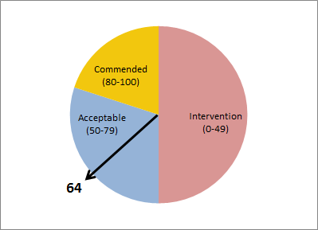

The state would then set threshold index scores based on its long-term targets for progress to determine whether a school has met an acceptable standard of achievement in each content, requires attention in this area, or, in rare cases, deserves commendation.

1b. Growth
Even if students enter school substantially behind grade level, and achieving proficiency in a single year is an unrealistic expectation, all students regardless of their starting points should be able to demonstrate normative growth from one test administration to the next. To measure this, the system uses student growth percentiles (SGPs) and seeks to determine how many students are attaining growth at or above a target percentile statewide. The target percentile would be set based on research that suggests unless a student makes adequate growth (roughly 35 SGP), he or she will actually lose ground relative to peers. Schools with smaller percentages of students below the target SGP would be outperforming the state in growth, while schools with greater percentages below this threshold would be underperforming.

Table 2. Growth Example
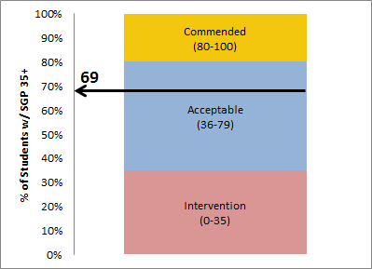

2a. English Language Proficiency
ESSA expects that learners of English should achieve English Language Proficiency in five years’ time. Therefore, a school that has a very low percentage of English learners enrolled for more than five years would be helping to meet that goal. However, the system should not perversely incentivized exit for ELs not yet ready, so, as required by the ESSA, all monitored students should be assessed for gaps on all other indicators as a population of interest (more on this in 3 below).

Table 3. Students Exiting ELL Status Example
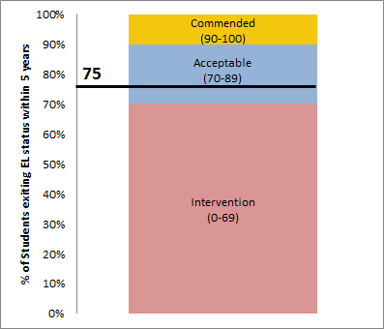

2b. English Language Proficiency Growth
Because the above element only focuses on ELs that exit, we must also account for ELs who are still working towards English language proficiency. In order to capture the growth of these ELs our system measures the number of ELs making a typical year’s worth of growth (compared to similarly performing students) as measured by an English language proficiency assessment, such as ACCESS. The state would set thresholds for what percentage of ELLs make this amount of growth and assess a school’s progress against this threshold.

Table 4. English Language Proficiency Growth Example
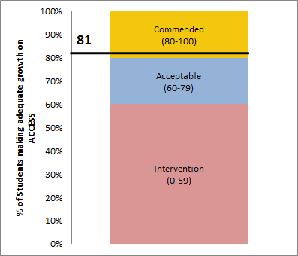
3. Equity
For each of the four elements above, our accountability system also takes into account school-level disparities of performance of populations of interest (POIs) compared to the state’s “all students” performance. If all of a school’s POIs show no gaps from the state’s “all students” population, then that school is providing an equitable education to all of its populations and mathematically reducing the statewide correlation between membership in a POI and educational achievement. However, it is also possible a school could be contributing to closing the statewide disparities in achievement even if a given POI in that school is not performing at least as well as the state’s “all students” population. As long as the POI in that school has a narrower performance gap than the same POI statewide, that school is helping narrow the achievement gap, albeit more modestly than if they achieve complete parity. Given this fact gap closure ratings would have three tiers of performance: Equitable and gap-closing, not equitable but gap-closing, and not equitable and not gap closing.

A somewhat unusual feature of our system is that it does not explicitly examine racial and ethnic populations as part of the gap closure analysis. While there are well-understood causal reasons for the academic underachievement of students with disabilities, students living in poverty and students acquiring English, it is problematic to assume that factors that should not predict academic achievement do, in fact, play a role. To promote a system based on conclusions from outcomes rather than assumption based on inputs, we therefore consider as a POI the bottom quartile of performers in a school. This focuses attention specifically on the students who need it most. Furthermore, it becomes a meaningful metric even in schools with little racial diversity.

In order to continue to safeguard against institutional bias, the system would also consider the composition of the lowest performing quartile of students in terms of race. The state would set a disproportionality cut score for any of the performance metrics for historically underserved races and could therefore identify a school for intervention if, for example, the population of their lowest quartile of students included a disproportionate percent of its African American students.

The POIs for each metric would be as follows:
1a. and 1b. Student achievement on the state test and Adequate student growth
  - Students from low socio-economic backgrounds (Low SES)
  - Students with disabilities (SWDs)
  - Students exited from EL status within the last four years (MELs)
  - Students performing in the bottom quartile in a given school (Bot 25%)
2a. and 2b. On-time (within five years) EL exit and Adequate ELP growth
  - Students from low socio-economic backgrounds
  - Students with disabilities

Table 5. Equity in Achievement Example
Pop. of Interest | Statewide Index Score | School Score/∆ from All Students/ ∆ from matching POI | Status
All Students | 71 | 64/NA/NA | N/A
Low SES | 62 | 55/-16/-7 | Not Equitable & Not Gap Closing
SWDs | 41 | 57/-14/+16 | Not Equitable, but Gap Closing
MELs | 69 | 77/+6/+12 | Equitable & Gap Closing
Bot. 25% | 49 | 50/-21/+1 | Not Equitable, but Gap Closing

4. School-wide Engagement
Finally, ESSA allows for additional indicators of school quality beyond performance on the state test. For secondary schools, our system would measure 4,5, and 6 year graduation rates as well as schools’ success engaging young people in school-based activities through which students earn something of post-graduation value, such as an industry-recognized credential, college credit, certified bilingualism, or completion of advanced coursework and exams likely to earn college credit. However, as we are modeling for an elementary school accountability system in this context, the system values the engagement of adults and children in their educational experience. As a proxy for engagement, we use chronic absenteeism (when absences account for 10% or more days of school missed in a given year). Research suggests that chronic absenteeism, particularly in early years, is highly correlated with future educational challenges. Additionally, research also suggests that a teacher is the single largest in-school contributor to a student's success, and as such, it is critically important that teachers be present consistently. The state would set thresholds for school-level percentages of students and teachers chronically absent to determine how well schools were doing on this metric.

Table 6. Teacher Chronic Absenteeism Example
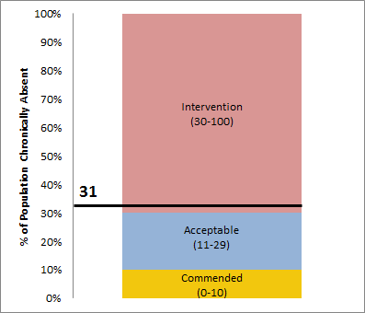

Identification for intervention and commendation

As noted throughout this proposal, the state would set a pace for progress toward the goals and establish cut scores and criteria for commendation, good standing, and low performance for each of the above indicators. All of these judgements would be made based on a three year rolling average to minimize yearly or cohort-specific “bounce” and ensure that we identify more lasting trends in school strengths and weaknesses.

The final result must serve each of our audiences well. For the state accountability office, patterns in low performance, such as weak indicators across several equity measures, would result in targeted state intervention. The state would also set a threshold for the number and type of areas of concern that would result in Priority status and comprehensive state intervention.

For families and local educators, the state would publish annually a one page school report listing each of the 28 indicators and at what level the school performed. We imagine a blue dot for acceptable performance, a red dot for poor performance, and a gold star for commendable performance. The report would include a summary paragraph to help families and educators interpret it. It would be specific to the school and built from three standardized sentence stems:
- First Sentence (Summary)
  - This school is commended for exceptional performance in multiple areas. OR
  - This school is in good standing.
OR
  - This school is in good standing. However, due to persistent causes for concern in these particular areas, this school is identified as requiring targeted state intervention….
OR
  - Due to multiple, persistent causes for concern in many areas, this school is identified as requiring comprehensive state intervention.
- Second Sentence: This school does particularly well at...
- Third Sentence: Causes for concern at this school are…

Table 7. Sample Comprehensive School Overview
✮ denotes commended performance
● denotes acceptable performance
● denotes performance in need of intervention

Academic Performance Indicator | Status
 | English Language Arts | Mathematics
Achievement | ● | ✮
Achievement Equity - SES | ● | ●
Achievement Equity - SWDs | ● | ●
Achievement Equity - MELs | ✮ | ✮
Achievement Equity - Bot 25% | ● | ●
Academic Growth | ✮ | ●
Growth Equity - SES | ● | ●
Growth Equity - SWDs | ● | ●
Growth Equity - MELs | ● | ●
Growth Equity - Bot 25% | ● | ●
English Language Proficiency Indicator | Status
Exit from EL Status within 5 years | ●
Equity in exit from EL Status - SES | ●
Equity in exit from EL Status - SWDs | ●
Student Growth on ACCESS | ✮
Growth on ACCESS equity - SES | ●
Growth on ACCESS equity - SWDs | ●
School Engagement Indicator | Status
Chronic Absenteeism - Student | ●
Chronic Absenteeism - Educator | ●

School Summary:
This school is in good standing. The school does particularly well regarding
- achievement in mathematics generally,
- achievement in English language arts and mathematics for English, learners exited from English learner status within the last four years,
- academic growth in English generally,
- and growth for English learners in achieving English language proficiency.
Causes for concern at this school are
- the academic performance in English and math for students from low-income backgrounds,
- academic performance in math for students with disabilities,
- the growth of students in the schools bottom quartile of performers,
- the growth for English learners in achieving English language proficiency for students with disabilities,
- and the levels of chronic absenteeism of educators.

