ESSA Accountability Design
A Proposal by the Prichard Committee Student Voice Team
The objectives of our state accountability system are:
- to create a holistic view of school quality through both academic and nonacademic indicators of success and
- to provide students, parents, teachers, administrators, and other stakeholders with the information they need to be effective advocates, understand where potential problems are within their schools, and strive for all students to receive a beneficial educational experience.
School accountability measures are most effective when they identify what a school is contributing to students, not what students are contributing to a school.¹ Our system, by focusing on these objectives, will encourage schools to use their resources in the most effective ways and facilitate improvement by including all invested parties, building on the idea that it takes a village to educate a child.
Schools will be evaluated on four indices which will be individually scored, weighted, and combined to indicate a school’s overall rating:
- Academic Proficiency: 31.25%
- Student Progress Over Time: 37.5%*
- Closing Performance Gaps: 25%*
- School Climate: 6.25%
*If the school has fewer than 20 students in a subgroup, then that subgroup will not be included in Index and 6.25% will be moved to Index 2.

Index 1: Academic Proficiency
Annual statewide testing would measure and test student competence for both English Language Arts and Math, with equally weighted scores, beginning in the third grade and continuing through fifth. The National Research Council has concluded that students who are not moderately-skilled readers or adequately exposed to mathematiques by the end of the third grade are unlikely to graduate from high school; results that reflect these trends prove powerful resources for states to advocate for more coordinated, effective learning systems.² The critical analysis, reading to learn, text interpretation, language, and writing skills emphasized through the English language arts tests will create strong skills for future subjects.³ Similarly, emphasizing a strong foundation in math will prepare students for upper level math and science classes.

Index 2: Student Progress Over Time
Student Progress Over Time will be assessed using the Colorado Growth Model.⁴ Schools will be compared graphically by their Median Student Growth Percentiles (SGP) and the Percentage of Proficient/Distinguished Students in a school. The graphs will provide students, teachers, parents, administrators, and other stakeholders with information on the impact an individual school has on its students when compared to other schools within the state. As a result, the public will be able to easily distinguish schools that are truly serving their students from schools that are only benefiting from well-prepared students, providing stakeholders with information on which schools are the best models. Inversely, using the Colorado Growth Model facilitates the general public’s conceptualization of how a low-performing school might be serving its students just as well as a high performing school, while also revealing the low-performing schools that need the most assistance.
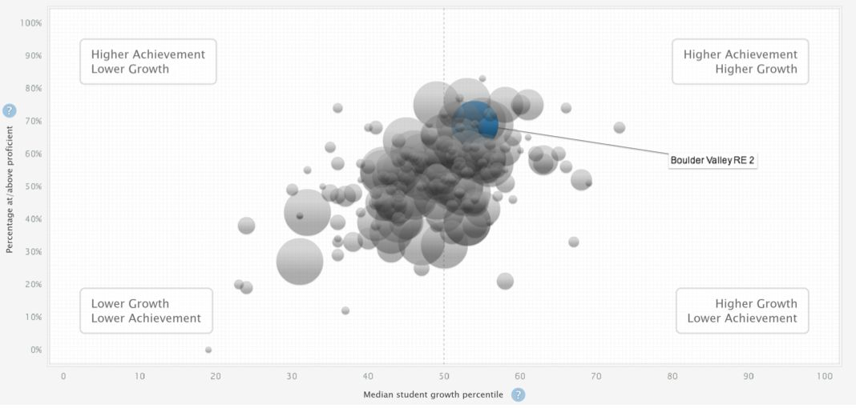
Source: Screenshot from Colorado Department of Education’s SchoolView System.⁵

Index 3: Closing Performance Gaps
Students defined as being heavily affected by an “achievement gap” or certain subgroups that regularly perform below or near average should always be an indicator of academic achievement when holding school systems accountable, as the school system should aim to enrich the lives and educational experiences of all who are enrolled. Students will be broken up into four traditional achievement gap subgroups for comparison, unless a student group does not meet the minimum size of 20 students. The four subgroups will be as follows:
- Black/Hispanic/Native American students
- Economically disadvantaged
- Former/current English language learners
- Students with disabilities
Based on Tennessee and Massachusetts District Accountability Systems.^{6, 7}

English Language Proficiency
To ensure that the needs of all English Language Learners are being met within their educational institutions, students who are deemed Limited English Proficient (LEP) will be tested to determine their level of English language proficiency. LEP is defined as “any student who does not speak English or whose native language is not English, and is unable to perform ordinary tasks in English.” Students who are multilingual, but fluent in English, will not be classified as LEP. Preliminary indicators of LEP will come from a home survey to determine the student's’ native language and whether they are English Proficient. Additional input on a student's’ progress can be taken from their respective teachers.
Once deemed LEP, students will be tested on their listening, reading, and writing abilities. While tests will vary according to grade level (e.g. Writing words in kindergarten versus writing a short composition in the fifth grade), every student will be tested on English language arts each year until deemed English Proficient.
Once a student achieves a benchmark score, determined by individual schools, teachers will evaluate students and a parent conference will be held to determine whether the student can be classified as English Proficient.
Before a student is classified as English Proficient, they will receive the following accommodations on state assessments:
- First year of enrollment in U.S. schools:
  - Students are tested in all areas
  - Students’ scores are not calculated into their school’s scores, but the aggregate scores must be reported by the school
- Second year of enrollment in U.S. schools:
  - Students’ scores will only be measured as part of Subindex 3B
- Third year of enrollment in U.S. schools:
  - Students scores are calculated normally

Index 4: School Climate
It is appropriate that student ideas are at the forefront of identifying issues concerning the school climate, as students are the chief stakeholders in schools. Students would take surveys that would include questions about teacher and student engagement, constructive student voice, communication among students, communication between students and teachers/administrators, cohesiveness of the student body, effective use of resources, encouragement of creativity, and student support. Fairman and Clark found these factors be present in positive school climates.⁸
The survey will be created by the state and evaluated by the state. The student on a one to five scale will evaluate each of the factors. The responses will be averaged for each survey and then each survey will be averaged overall to find the school’s overall school climate score. The responses to each question will also be averaged across all surveys and released so the school and public will know how the school does on specific parts of school climate.
Students will also be asked a short answer, open-response question about any issues or concerns the student has about the school. These responses will not be included in the school’s score. The state will report to the school all of the responses, but will only release to the public responses which appeared in 5% or more of the surveys. These responses would only have to be about the same overall issue and not identical, and all identifying information will be removed. This will help schools address problems that they may not be aware of and are not directly addressed by the ranked questions.
The intent of these surveys is to create a knowledge base of what can be done to improve each school on a specific, student-based level. Positive change in schools is more effectively brought about through changes in climate than changes in structure.⁹ This measurement of school climate effectively identifies problems within schools, as is one of our objectives, and therefore gives administrators the information they need to design beneficial changes that will enhance the educational experience of students.

School Rating System
Index | Raw Score |  | Points Earned | Points Possible
Academic Proficiency | Chart Below | X1 |  | 25
Student Progress Over Time | See Below | x(Points Possible) |  | 30*
Closing Performance Gaps | See Below | x5 |  | 20*
School Climate | Mean of average score for all surveys | x1 |  | 5
Total |  |  |  | 80
*For every subgroup exemption a school receives, 5 points will be subtracted from the points possible for Closing Performance Gaps and 5 points will be added to the points possible for Student Progress Over TIme

Index Raw Scores

Index 1: Academic Proficiency
Percentage of Students Scoring At or Above Proficiency |  | Score |  | Percentage of Students Scoring At or Above Proficiency |  | Score
Low | High |  |  | Low | High
96 | 100 | 25 |  | 44 | 48 | 12
92 | 96 | 24 |  | 40 | 44 | 11
88 | 92 | 23 |  | 36 | 40 | 10
84 | 88 | 22 |  | 32 | 36 | 9
80 | 84 | 21 |  | 28 | 32 | 8
76 | 80 | 20 |  | 24 | 28 | 7
72 | 76 | 19 |  | 20 | 24 | 6
68 | 72 | 18 |  | 16 | 20 | 5
64 | 68 | 17 |  | 12 | 16 | 4
60 | 64 | 16 |  | 8 | 12 | 3
56 | 60 | 15 |  | 4 | 8 | 2
52 | 56 | 14 |  | 0 | 4 | 1
48 | 52 | 13
Ranges include the low-bound percent but exclude the high-bound percent. For example a score of 20 would be given to 76% proficiency but a score of 21 would be given to 80% proficiency. Percents will not be rounded except for a percent less than 0.1% smaller than the low-bound percent of the next point on the scale, which will be rounded up to the low-bound percent

Index 2: Student Progress Over Time
For every student who demonstrates “typical growth”, that is, has an SGP of 40 or greater, a school will be awarded .6 points. For every student who demonstrates “advanced growth”, that is, has an SGP of 60 or above, will be awarded 1 point. The sum of these two values divided by the total number of participating students will be the school’s raw score for Index 2. (This calculation will include students’ scores in both English language arts and math)

Based on Kentucky’s Unbridled Learning Accountability Model.¹⁰

Index 3: Closing Performance Gaps

The goal for all groups is to achieve or exceed an SGP of at least one point above the “typical growth” for the state Groups with a median SGP of 41 or higher receive .6 points. Groups that achieve “advanced growth” will receive 1 point. The sum of these will be the school’s raw score for Index 3. (This calculation will include students’ scores in both English language arts and math)

Index 4: School Climate
The score for school climate will be found by:
- Averaging the answers of each survey to find each student’s overall school climate assessment. Answers to the open-ended question will not be included.
- Rounding the average to the nearest whole number score. Digits 1-4 round down, digits 5-9 round up.
- Finding the student body mean overall assessment of school climate.

School Ratings
Schools will be put into four categories based on the table below. The score for each Index will also be reported. The performance of the subgroups listed in Index 3 with 20 or more students will also be reported. Additionally, participation rates overall, for each Index, and for the subgroups listed in Index 3 with 20 or more students will be reported.
Points Earned | School Rating
64-80 | Exceeds Expectations
41-63 | Meets Expectations
27-40 | Reaching Expectations
0-26 | Below Expectations

Participation Rate
All schools must meet a participation rate of 95% overall, for each index, and for all subgroups listed in Index 3 which have 20 or more students. Any school failing to meet the 95% participation for any part will:
- still have the scores for all indices reported including indices with inadequate participation,
- be rated as “Below Expectations: Inadequate Participation” regardless of the total score of other indices,
- and have an Intervention.

Interventions
Schools ranking in the bottom 5% of the state will be required to propose goals or targets and to plan the steps to achieve them. This will occur through a Planning Committee which will be made up of and directly involve stakeholders including students, parents, teachers, administrators, members of the state education department, and other stakeholders. Involving all affected stakeholders in the process is vital to the system's effectiveness because it will increase the probability that all ideas are heard and all resources used.
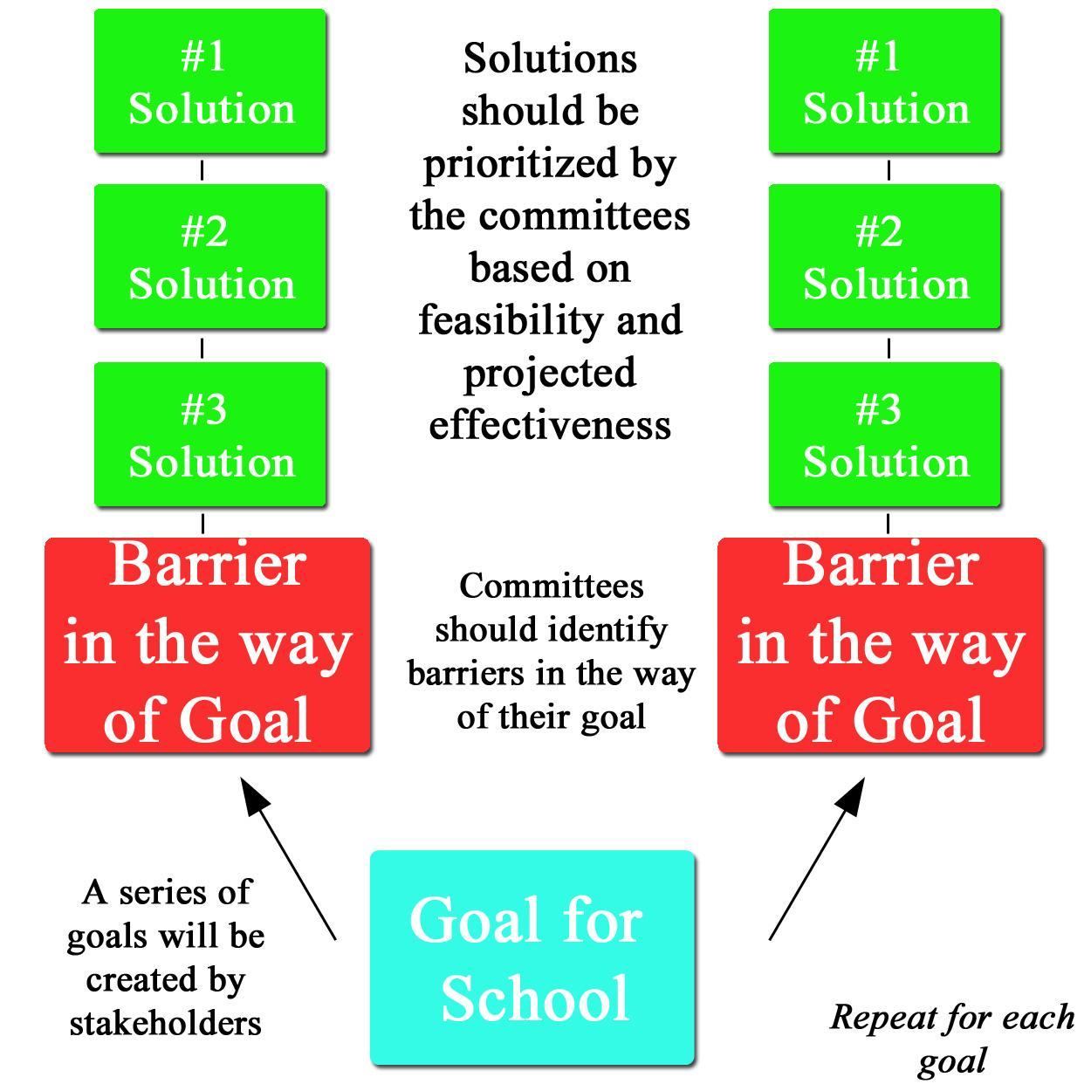
The Planning Committee must pinpoint where the school needs to be, identify barriers stopping the school from getting there, and recommend actions to solve the barriers. The Committee’s evaluation of where the school needs to be must be reasonable, achievable in no less than 10 years, and not overly soft to allow the school to praise progress when little is taking place. The Committee must then identify the barriers that hinder the school’s ability to reach the goals set forth. The barriers should be grouped together if they deal with a similar issue or area, and there should be no duplicates. The members of the Committee then have to recommend the best course of action to break down the barriers. The Committee should consider the views of all stakeholders included and comments from the public during the process with the underlying goals of inclusion and transparency.
The school must then begin the implementation of the Committee’s recommendations. To ensure the recommendations are being followed and implemented, all stakeholders should monitor the school’s implementation process.
Schools which have inadequate participation will not be funded by the
This tier process is based off Florida's Guide to 8-Step Planning & Problem Solving for Continuous Improvement.¹¹

Notes
- Hanushek, E. A., Machin, S., & Woessmann, L. (2010). Handbook of the economics of education, 3, 383-421. DOI: 10.1016/S0169-7218(11)03008-5
- Achieve (2013). Creating a P-20 continuum of actionable academic indicators of student readiness. Retrieved from http://www.achieve.org/files/StudentReadinessIndicators.pdf
- Chingos, M. M., & West, M. R. (2015). Why Annual Statewide Testing Is Critical to Judging School Quality. Brookings. Retrieved from http://www.brookings.edu/research/papers/2015/01/20-chalkboard-annual-testing-chingos-west
- Carey, K. & Manwaring, R. (2011). Growth models and accountability: A recipe for remaking ESSA. Education Sector.
- Screenshot of Colorado Department of Education’s SchoolView. Retrieved from https://www.cde.state.co.us/schoolview
- Tennessee Department of Education (2015). 2015 District Accountability Overview. [PowerPoint slides]. Retrieved from https://www.tn.gov/assets/entities/education/attachments/acct_overview_2015.pdf
- Massachusetts Department of Elementary and Secondary Education (2015). School Leader’s Guide to the 2015 Accountability Determinations. Retrieved from http://www.mass.gov/edu/docs/ese/accountability/annual-reports/school-leaders-guide.pdf
- Fairman, M. & Clark, E. (1982). Organizational problem solving: An organizational improvement strategy. Fayetteville, AK: Organizational Health Diagnostic and Development Corp.
- Kytle, A. W. & Bogotch, I. E. (2000). Measuring reculturing in national reform models. Journal of School Principalship, 10, 131–157.
- Kentucky Department of Education (2012). Unbridled learning accountability model (With focus on the next-generation learners component). Retrieved from http://education.ky.gov/comm/UL/Documents/WHITE%20PAPER%20062612%20final.pdf
- Differentiated Accountability State System of School Improvement, Florida Administrative Code, Rule 6A-1.099811 (12 Dec. 2014).

About Us
Consisting of over 85 self-selected middle and high school students and college undergraduates, the Prichard Committee Student Voice Team is an extension of the Prichard Committee for Academic Excellence, an independent, nonprofit organization that mobilizes citizens to improve Kentucky schools. The Student Voice Team integrates students as full partners in that work.

ESSA Proposal Team

Lydia Burns  Team Leader & Editor  Academic Standards Chair  West Jessamine High School | Hiatt Allen  Co-Editor  Associate Student Director  The American University
Tsage Douglas  Index 3 Researcher & Writer  Scott County High School | Nancy LoGuidice  Index 3 Researcher & Writer  Sacred Heart Academy
Morgan Rehm  Index 2 Researcher & Writer  Scott County High School | Jamie Smith  Index 4 Researcher & Writer  Henry Clay High School
Callaway Stivers  Ratings Researcher & Writer  Lafayette High School | Dustin Summers  Interventions Researcher & Writer  George Rogers Clark High School
Sam Swayze  Ratings Researcher & Writer  Lafayette High School | Sahar Zadeh  Index 1 Researcher & Writer  Paul Laurence Dunbar High School
Rachel Belin
Student Voice Team Director
Prichard Committee for Academic Excellence

271 West Short St. Suite 202 | Lexington, KY 40507
(859) 233-9849 x233 | studentvoiceteam@prichardcommittee.org
prichardcommittee.org/studentvoiceteam
@pcstuvoiceteam

